Promotion of the
HPV Vaccine
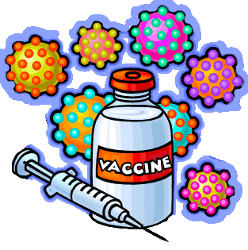
Caroline Fruehauf
Molly Morgan
Raven Williams

Table of Contents
Section One: Introduction…………………………………………………....…3 – 6
Section Two: Social Assessment……………………………………………….7 – 9
Section Three: Epidemiological, Educational, and Ecological Assessments..10 – 16
Section Four: Mission Statement, Goals, and Objectives……………..…….17 – 20
Section Five: Theoretical Basis of the Program……………………..………21 – 24
Section Six: Implementation and Evaluation………………………………..25 – 33
Section Seven: References………………………………………………..…34 – 38
Section One: Introduction
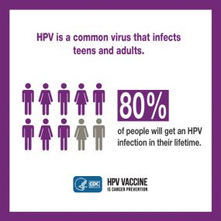
The Human Papillomavirus (HPV)
The human papillomaviruses are “a group of more than 200 related viruses, of which more than 40 are spread through direct sexual contact” (National Cancer Institute, 2018). Almost eighty million people in the United States are currently infected with HPV and about fourteen million people become infected each year (Center for Disease Control and Prevention [CDC], 2018). HPV can be transmitted in multiple ways including vaginal, oral, or anal sex (CDC, 2018). Mothers can also transmit the infection to their children during pregnancy (CDC, 2018). HPV can be transmitted whether or not the infected person has signs or symptoms and symptoms can take years to develop (CDC, 2016). The asymptomatic nature of HPV is one of the reasons the virus is so common. According to the CDC, “80% of people will get an HPV infection in their lifetime” (2018). HPV can sometimes go away on its own and may not cause any health problems, but if it does go untreated or undetected, it can lead to cancer and other health problems, such as genital warts (CDC, 2016). However, the HPV vaccine is available to protect against the human papillomavirus infection and thus prevent future health problems.
“Every year in the United States, HPV causes 33,700 cancers in men and women” (CDC, 2018). The vaccines that are currently available can work to prevent HPV infections that commonly cause cancer (CDC, 2015). “Clinical trials showed HPV vaccines provide close to 100% protection against cervical precancers and genital warts. Since the first HPV vaccine was recommended in 2006, there has been a 64% reduction in vaccine-type HPV infections among teen girls in the United States” (CDC, 2018). In countries “where HPV vaccination coverage is higher than in the United States, large decreases have been observed in these HPV-associated outcomes” (CDC, 2018). This illustrates the effectiveness of the vaccine in decreasing the rate of HPV in other countries and in the United States.
Currently Gardasil 9 is the only vaccine available in the United States (National Cancer Institute, 2018). The Food and Drug Administration, also known as the FDA, has approved Gardasil, Gardasil 9, and Cervarix in the past and Gardasil and Cervarix are still available in other countries (National Cancer Institute, 2018). “All three vaccines prevent infection with HPV types 16 and 18, two high-risk HPVs that cause about 70% of cervical cancers and an even higher percentage of some of the other HPV-caused cancers. Gardasil also prevents infection with HPV types 6 and 11, which cause 90% of genital warts. Gardasil 9 prevents infection with the same four HPV types plus five additional cancer-causing types (31, 33, 45, 52, and 58) (National Cancer Institute, 2018). Currently, the CDC recommends the HPV vaccine “for young women through age 26, and young men through age 21” (National Cancer Institute, 2018). It is also recommended that other groups who are more susceptible to being infected with HPV also receive the vaccine.
This includes:
- “young men who have sex with men, including young men who identify as gay or bisexual or who intend to have sex with men through age 26;
- young adults who are transgender through age 26; and
- young adults with certain immunocompromising conditions (including HIV) through age 26” (CDC, 2017.
A primary prevention program could be implemented to work to further reduce the incidence rate of HPV in the United States. The CDC recommends that girls as young as eleven and boys as young as nine can be vaccinated (2018). This means that the parents of these children must be the target group since most children under the age of eighteen cannot decide for themselves what vaccines they will receive. At such a young age, many of the children that the CDC recommends receive the vaccine would likely not know what HPV is or how someone may become infected.
The Effects of HPV
According to the Centers for Disease Control and Prevention, “most people with HPV never develop symptoms or health problems...but, sometimes, HPV infections will last longer, and can cause certain cancers and other diseases.” (2018). According to the National Cancer Institute, “widespread HPV vaccination has the potential to reduce cervical cancer incidence around the world by as much as 90%” (2018). Treatments for cervical cancer include cryosurgery, laser surgery, conization, a hysterectomy, radiation treatments, and chemotherapy (American Cancer Society, 2016). All of these treatments have risks and side effects, which means that even if someone who developed cervical cancer due to a HPV infection is in remission, they will likely have lifelong effects from their treatment (American Cancer Society, 2016). According to the National Cancer Institute, the side effects of cancer treatments and cancer include anemia, appetite loss, fatigue, fertility issues, nausea, nerve problems, pain, edema, bleeding, bruising, sleep problems, bladder problems, hair loss, and many others. Cervical cancer is not the only cancer linked to HPV.
“The HPV infection can cause:
- cancers of the cervix, vagina, and vulva in women;
- cancers of the penis in men; and
- cancers of the anus and back of throat, including the base of the tongue and tonsils (oropharynx), in both women and men” (CDC, 2018).
Cancer, even non-fatal cancer, affects people for their entire lives. Treatments for cancer are often devastating and can interfere with future pregnancies, fertilities, and day-to-day life. By getting a vaccination that will prevent a HPV infection, future cancer and other health problems can be prevented.

Section Two: Social Assessment
Who is affected by HPV?
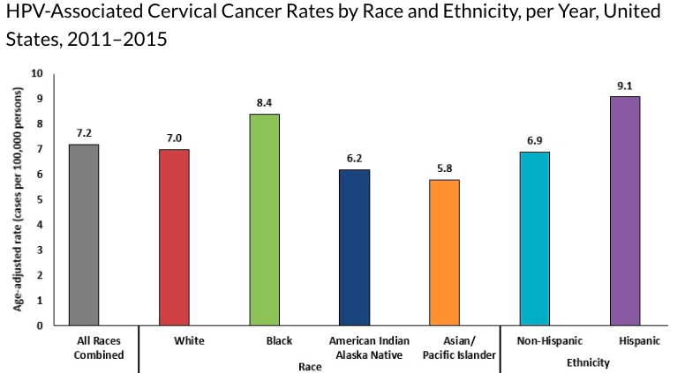
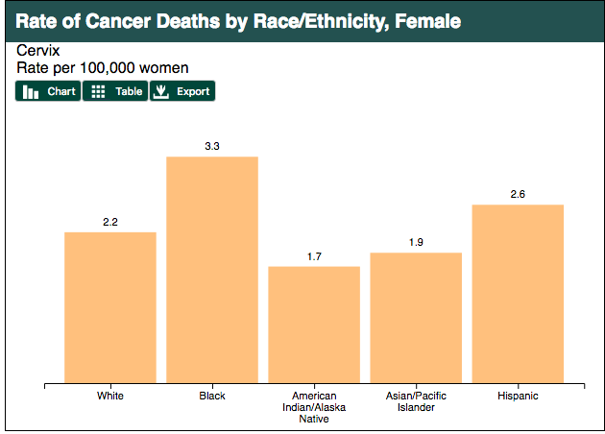
There are millions of people currently infected with HPV in the United States (CDC, 2018). In South Carolina alone, around 13 people out of every 100,000 people were diagnosed with a HPV-related cancer between 2011 and 2015 (CDC, 2018). Of the millions of people that have HPV, African American women over the age of forty have a higher risk of being diagnosed with these HPV related cancers than others (KFF, 2018). They are also the most affected population in the United States. Around 8.4 per 100,000 African American women in the United States were diagnosed with cervical cancers that were HPV related (KFF, 2018). African American women also had the highest cervical cancer morbidity rate with 3.3 deaths per 100,000 women (KFF, 2018). This is compared to white women with a morbidity rate of 2.2 and Hispanic women with a rate of 2.8 (KFF, 2018).
Since the HPV vaccine only came out in July of 2006 (KFF, 2018), older women would likely not have received this vaccine. Now that the vaccine is widely available, it is important that programs are implemented to reduce the incidence rate of HPV in older African American women in the future by increasing the use of the HPV vaccine now. Many African American parents do not have access to the HPV vaccine for their children which can lead them to be more susceptible to HPV related cancers. The Human Papillomavirus (HPV) vaccine is essential for younger women especially young African American women so they can prevent HPV related cancers and other health issues later in life. Especially younger women who have a family history of HPV-related cancers and already have a higher chance of developing these diseases. The HPV vaccine is a priceless tool in working towards preventing these cancers. For these reasons, the target population of this program are African American young women between the ages of eleven and fifteen.
Where do young, African American women live, work, play, and pray?
Human papillomavirus (HPV) is very common throughout the world, infecting both men and women every day (CDC, 2018). According to the CDC, and data from 2011 to 2015, “about 42,700 HPV-associated cancers occur in the United States each year…” (CDC, 2018). Nearly half of the U.S is infected with HPV and it is responsible for about 91% of cervical cancers in women (CDC, 2018). Cervical cancer is the most common cancer resulting from HPV amongst women. Data reveals that African American women in the United States have a higher infection rate than women of other ethnicities (CDC, 2018). After a study was conducted in 2011 that researched HPV-associated cancer rates in each state, it was noted that there were higher rates of HPV in southern states (CDC, 2018). South Carolina was one of those states with a higher rate of HPV (CDC, 2018). There are many South Carolinians who have not been vaccinated, including young African American women and girls, leaving them vulnerable to the virus (CDC, 2018).
After a study at the University of South Carolina was conducted in 2004, researchers found that African American women are most likely to have a constant high risk of HPV than other races (Everyday Health, 2018). These findings show that either genetics, or lack of access to medical care could be the problem. Many African American families have from low income jobs, which makes getting proper medical care hard, resulting in less regular physical examinations than other ethnicities. Religion, also plays a big role in why many African American individuals lack medical care. Most African American South Carolinians attend historically African American protestant churches that sometimes encourage relying on God and praying to treat illness (PEW Research Center, 2015). It is also a common belief that children shouldn't be vaccinated because of their race or age. According to Health Impact News, there have been recent findings that African American parents tend to react differently to certain vaccines, giving them a “higher risk to be injured or killed by vaccines than other children” (Health Impact News, 2018). Around 27% of South Carolina’s population is African American, and an estimated 50% of those African American South Carolinians are female (Suburban Stats, 2018). This means that this large population of people are at a high-risk for becoming infected with HPV and developing HPV-related cancer later in life. Implementing a program that would increase the use of HPV vaccinations, like Gardasil 9, can save them from life threatening illnesses like cancer later in life.

Section Three: Epidemiological, Educational, and Ecological Assessments
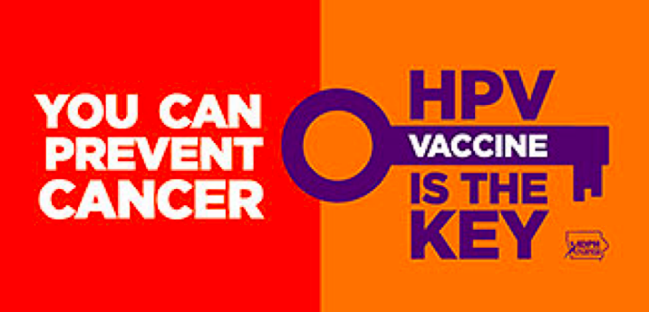
Overview of Behavioral and Environmental Risk Factors
African American women have the highest mortality rate for HPV related cancers because of their lack of access to healthcare. These women are more likely to get diagnosed at a later stage in their cancer because of their lack of healthcare (Arvizo & Mahdi, 2017). When a person is denied equal access to health care they are more likely to have diseases and conditions that have gone unnoticed because they are not receiving a physician's attention as much as the average person. It would be harder to recognize symptoms of a disease or illness as dangerous if the patient does not visit a physician frequently. African American women’s lack of access to healthcare is caused in part by socioeconomic factors as well as cultural factors. Many African American individuals are wary to trust medical professionals because of a history of mistreatment of African American patients in the past, such as the Tuskegee incident, in which researchers did not treat many African American men for syphilis for a research project, causing multiple fatalities, as well as the spread of infection to the men’s sexual partners and children (Dawson, 2018). Lack of access to healthcare, both from mistrust of medical professionals as well as other factors such as access to medical insurance, affects not only young, African American women’s access to the HPV vaccine but their diagnosis and treatment if they do not receive the vaccine and develop cancer as a result of a HPV infection.
Behavioral risk factors that increase the chance of individuals, including young, African American women not receiving the HPV vaccine include not going to the doctor regularly, unsafe sex, not receiving education about safe sex, and the influence of religion. Each of these are factors whose effect can be reduced by changing frequently used behaviors. One environmental risk factor is the fact that rural areas often have less doctors or specialized OBGYN’s (Arvizo & Mahdi, 2017). “Equal access to healthcare may eliminate most of the disparity. A study in women with cervical cancer who sought treatment within the United States military healthcare system found no difference in treatment or 5- and 10-year survival rates between African American and white women,” (Arvizo & Mahdi, 2017). This shows that when citizens are receiving equal health care that there is no difference in survival rates between races. There is likely to be a lack of free or reduced cost healthcare in these areas for poverty stricken people which can be an obstacle for these women to be able to receive the HPV vaccine. Even if this type of healthcare is available, individuals may not be aware it is there or may not take advantage of it due to lack of physical access or for cultural reasons, such as being embarrassed or nervous about the situation. Risk determinants are factors that cannot be changed such as poverty, genetics, and family history of HPV related cancers. Other factors include limited knowledge or misinformation about HPV and the HPV vaccine, public opposition to vaccinations, and knowledge about how to practice safe sex. These are all factors that correspond with diagnoses of HPV related cancers and most likely contribute to why African American women are more likely to be diagnosed with these cancers.

Priority Analysis Matrix
 | More Important | Less Important
More Changeable | - Limited knowledge of HPV vaccine (including parents of children recommended to receive the vaccine)  - Misinformation about the HPV vaccine  - Access to the vaccine due to location  - Physician recommendations | - Knowledge about how to practice safe sex
Less Changeable | - Socio-economic status  - Cultural and religious beliefs  - Public opposition to vaccinations | - Genetics

Young, African American women between the ages of eleven and fifteen are more prone to HPV due to many behavioral risk factors. In the chart above, you will see that some of these factors are changeable and others are more change resistant. It is important that we further educate the parents of children who are recommended to get the HPV vaccine as well as other individuals who themselves are recommended to receive the vaccine. Studies have shown that there needs to be a change in how parents view the vaccine (Arvizo & Mahdi, 2017). For example, some parents believe that the HPV vaccine would encourage their children to have sex and to not practice safe sex (Arvizo & Mahdi, 2017, 2018). These parents should also be educated on how to educate themselves about the vaccine, ask for a physician's recommendation, and also how and where to receive the vaccine (Arvizo & Mahdi, 2017, 2018). The way that parents and patients are provided with the information is also very important when trying to improve vaccination rates and should be considering during planning of education programs. These aforementioned risk factors are the ones that are more susceptible to change, allowing high HPV infection rates to decrease if programs were implemented that focused on these factors. The National Vaccine Advisory Committee (NVAC), is one program that provides educational material for children and parents of the patient and provides them with information on the vaccine. Educating the caregivers and patients has been seen to be “effective in increasing vaccination uptake and completion” (Cole, 2017). This indicates that changing behaviors such as education, physician recommendations and providing education about safe sexual behaviors are possible to do and likely easier and more likely to succeed then working to change other risk factors.
There are certain behavioral risk factors that are more resistant to change when dealing with improving vaccination rates. For example, religion and culture plays a large role in why some people do not allow their children to get vaccinated. Religion and cultural values are extremely resistant to change and programs that focused on changing these beliefs would likely not be as successful and take a much longer time than other programs. Access to healthcare also plays a large role in why these young, African American women are not taking advantage of the HPV vaccination or receiving general care from physicians. A lack of access to healthcare is important but is also extremely difficult to change and would need a lot of funding. Program committees cannot change the distance between where a person lives and the nearest healthcare facility who carries the vaccination and would need to bring more healthcare professionals to the patients. This can be extremely expensive and time consuming. The factors that are changeable have data that support their success and show an increase in HPV vaccinations rates where they have been implemented (CDC, 2018).
Key Predisposing, Reinforcing, and Enabling Factors for Not Receiving the HPV Vaccination
Factor Type | Factor | Explanation of Relationship with Behaviour
Predisposing | - No or limited education about HPV and the HPV vaccine  - Belief that only sexually promiscuous individuals need the vaccine  - Certain cultural and religious beliefs | - Individuals without proper education about the virus and vaccine may not understand what it will do or why they should receive it and so do not receive the vaccine  - The belief that only sexually promiscuous individuals need the vaccine would influence individuals who will not receive the vaccine because they believe that they do not need it or do not want to be labelled as sexually promiscuous as they view that label in a negative light  - Certain cultural and religious beliefs oppose vaccinations and this opposition influences the decision of parents whose children are recommended to receive the vaccination as well as individuals
Enabling | - Lack of physical access to the HPV vaccine  - Lack of fiscal access to the vaccine  - Parents unwilling to discuss the vaccine as it could lead to an uncomfortable discussion about sex with their children and others | - Lack of physical and fiscal access to the vaccine would mean that individuals who want the vaccine are unable to get it because of financial concerns or because they are not physically able to get access to a location that could provide the vaccination because of their location  - Parents may be unwilling to discuss the vaccine with their children because they do not want to discuss uncomfortable topics like sex with their children which would mean that their children do not receive the vaccination so that their parents can avoid discussing the topics with them or their doctors
Reinforcing | - Lack of support from family and friends for individuals that receive the vaccine  - Celebrity opposition of vaccines in general | - Family and friends may not support the vaccination due to religious, cultural, or personal beliefs which could influence the decision of individuals to take advantage of the vaccination  - Opposition from public individuals such as celebrities could influence an individual’s decision to receive the vaccine because they trust the celebrity and believe that they are more knowledgeable about the topic

Predisposing, enabling, and reinforcing factors can cause or influence health behaviors. Predisposing factors “are antecedents to the behavior that provide the rationale or motivation for the behaviour” (Green & Kreuter, 1999). One predisposing factor that influences the behavior of individuals who do not receive the HPV vaccine is having no or limited knowledge about the virus or vaccine. Individuals without proper education about the virus and vaccine may not understand what it will do or why they should receive it and so do not receive the vaccine. Another predisposing factor could be the belief that only sexually promiscuous individuals need the HPV vaccine. The belief that only sexually promiscuous individuals need the vaccine would influence individuals who will not receive the vaccine because they believe that they do not need it or do not want to be labelled as sexually promiscuous as they view that label in a negative light. Certain cultural and religious beliefs, another predisposing factor, oppose vaccinations, especially vaccinations that they believe encourage sexual behaviour, and this opposition influences the decision of parents whose children are recommended to receive the vaccination as well as individuals. Enabling factors “are antecedents to the behavior that allow a motivation to be realized” (Green & Kreuter, 1999). One enabling factor is lack of fiscal and physical access to the vaccine. Lack of physical and fiscal access to the vaccine would mean that individuals who want the vaccine are unable to get it because of financial concerns or because they are not physically able to get access to a location that could provide the vaccination because of their location. Another enabling factor may be that parents are unwilling to discuss the vaccine with their children because they do not want to discuss uncomfortable topics such as sex with their children which would mean that their children do not receive the vaccination because their parents want to avoid discussing the topics with them or their doctors. Reinforcing factors “are factors following a behavior that provide the continuing reward and incentive to continue or not continue the behavior” (Green & Kreuter, 1999). For example, some reinforcing factors are a lack of support from family and friends for individuals that receive the vaccine and celebrity opposition of vaccines in general. Family and friends may not support the vaccination due to religious, cultural, or personal beliefs which could influence the decision of individuals to take advantage of the vaccination. Opposition from public individuals such as celebrities could influence an individual’s decision to receive the vaccine because they trust the celebrity and believe that they are more knowledgeable about the topic. These factors can cause or influence health behaviors such as receiving or not receiving the HPV vaccine which could have lifelong effects for many individuals and groups, such as young African American women.

Section Four: Mission Statement, Goals, and Objectives
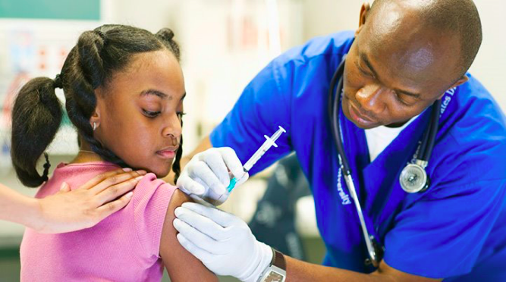
Mission Statement
We are committed to improving the physical health of individuals and communities in South Carolina; our mission is to improve the health education of middle and high schoolers in South Carolina, especially young African American girls between the ages of eleven and fifteen, so that there is an increase in the amount of individuals that receive the HPV vaccination and are better protected against the infection that can lead to cancers and other health issues later in life.
Program Goals
Program goals will include:
- Increased overall knowledge of the HPV and vaccine including increased knowledge of who needs the vaccine and what it does, how to receive the vaccine, and myths about the vaccine
- Reduced incidence rates of HPV in African American women
- Reduced the rates of HPV-related cancers in African American women
- Increased rates of HPV vaccinations in African American girls between the ages of eleven and fifteen
Process Objectives
- By October 15th, 2020, program planners will have hired and trained at least five staff members, such as health education specialists, who will educate program participants on the importance of the HPV vaccine.
  - Who – Program planners
  - What – Hire and train at least five staff members
  - When – By October 15th, 2020
  - To What Extent – Five staff members
- By October 15th, 2022, staff hired by program planners, such as health education specialists, will have visited at least 75% of public middle and high schools in South Carolina and educated the students and parents about the HPV vaccine.
  - Who – Staff hired by program planners
  - What – Visited at least 75% of middle and high schools in South Carolina and educated the students about the HPV vaccine
  - When – By October 15th, 2022
  - To What Extent – 75% of middle and high schools in South Carolina
Impact Objectives
- Upon completion of the program, 75% of program participants will be able to identify at least two reasons why they should receive the HPV vaccine.
  - Who – Program participants
  - What – Be able to identify at least two reasons why they should receive the HPV vaccine
  - When – Completion of the program
  - To What Extent – 75% of program participants
- Upon completion of the program, 75% of program participants will be able to identify at least two techniques they can apply when discussing the HPV vaccine with their guardian or medical provider so that they feel more comfortable when discussing the topic.
  - Who – Program participants
  - What – Identify at least two techniques they can apply when discussing the HPV vaccine with their guardian or medical provider so that they feel more comfortable when discussing the topic
  - When – Completion of the program
  - To What Extent – 75% of program participants
Behavioral Objectives
- After the completion of the program, at least 50% of program participants will report having previously discussed the HPV vaccine with a health care provider.
  - Who – Program participants
  - What – Report having previously discussed the HPV vaccine with a health care provider
  - When – Completion of the program
  - To What Extent – 50% of program participants
- After the completion of the program, 50% or more of program participants will have received at least one of the HPV vaccine shots and will report intending to successfully complete the entire HPV vaccination process if they have not already.
  - Who – Program participants
  - What – Report having received at least one of the HPV vaccine shots and will report intending to successfully complete the entire HPV vaccination process if they have not already
  - When – Completion of the program
  - To What Extent – 50% of program participants
Outcome Objective
- From 2018 to 2023, the overall rate of African American girls between the ages of eleven and fifteen years old in South Carolina who complete the HPV vaccination process will increase by 25% based on data collected by the Centers for Disease Control and Prevention (CDC).
  - Who – African American girls between the ages of eleven and fifteen
  - What – Increased rate of completed HPV vaccinations
  - When – 2018-2023
To What Extent – 25% of the target population

Section Five: Theoretical Basis of the Program
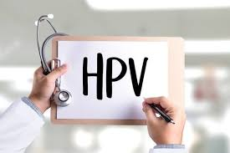
Health Belief Model
The Health Belief Model (HBM) focuses on the susceptibility and severity of health problems while also explaining the benefits of avoiding the threat (Guimaraes, 2018). The focus of the Health Belief Model makes it a uniquely prepared model for reviewing the HPV vaccine. In a journal article focusing on the predictors of HPV vaccine acceptability, Brewer and Fazekas use the Health Belief Model to explain that, “the reviewed findings, taken in combination with well-known heath behavior theories and the body of empirical literature on vaccination and related interventions, suggest that HPV vaccine programs in the United States should emphasize the high likelihood of HPV infection, high vaccine effectiveness, and physicians’ recommendations, and address barriers to vaccination” (2007). The Health Belief Model will be used to reinforce the importance of making the target population aware of why they should avoid HPV by receiving the vaccine and the importance of making these individuals aware of the severity and susceptibility of HPV and HPV-related cancers. The model will work to address perceived severity, susceptibility, and barriers held by the target population in order to increase the rate of vaccination for HPV.
HPV and the Health Belief Model
The Health Belief Model (HBM) focuses on an individual’s perceptions of the threat posed by a health problem, the benefits of avoiding that threat, and the factors that influence the decision to act (Guimaraes, 2018). The problem of HPV fits into the Health Belief Model because the perceived benefits of avoiding HPV, including lowering the risk of cancer, could influence the decision of an individual to act and receive the HPV vaccination. An individual’s perceived susceptibility to contracting HPV and later HPV-related cancers could also influence the individual to take action and receive the HPV vaccine. If an individual believes that they are not susceptible to become infected with HPV, it is unlikely that they would take action to receive the HPV vaccine as they would believe it to be unnecessary. An individual’s perceived severity of HPV could also influence their decision to take action. If an individual is unaware of the severity of HPV, such as the risks and effects of HPV-related cancers, it would make them less likely to receive the vaccination. Perceived barriers, such as stigma around sexually transmitted infections and financial barriers, could influence an individual to not receive the vaccination. All of these constructs are part of the Health Belief Model and are part of changing the behaviours of individuals in order to reduce the prevalence rates of HPV, especially among young African American women.
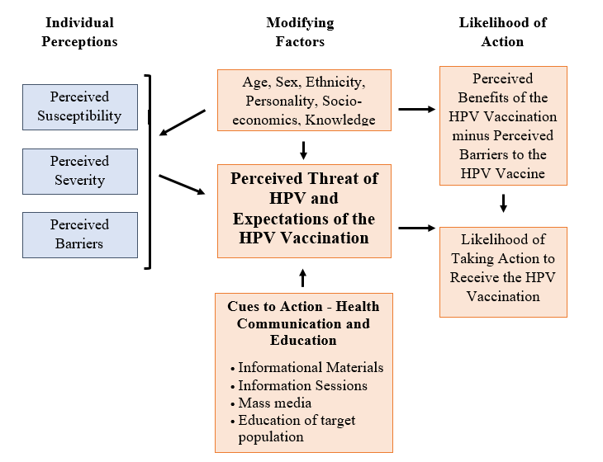
Intervention Strategies

Objective Type | Theory – Construct | Intervention Strategy | Possible Activities
Learning | HBM – Perceived Susceptibility | Health Education and Health Communication | - Brochures (and other printed materials) and websites with information about risk of HPV  - Information sessions to provide information about risk of HPV  - Mass media addressing risk
Behavioral | HBM –Perceived Severity | Health Education and Communication | - Information sessions to talk with guardians and patients about the consequences of HPV  - Mass media about consequences  - Printed information materials about consequences
Environmental | HBM – Perceived Barriers | Health Education and Communication | - Providing a list of clinics and pharmacies that offer the HPV vaccination  - Providing information about cost and payment for the vaccination  - Education about HPV that focuses on reducing stigma  - Education focusing on competency of individuals to overcome perceived barriers

Health education strategies provide opportunities to populations to gain in-depth knowledge about a particular health topic. Health communication strategies are designed to inform and influence both individual and community decisions in order to influence health (Guimaraes, 2018). Both health education and health communication strategies can be used to address perceived susceptibility, perceived severity, and perceived barriers about HPV and the HPV vaccine.

Section Five: Implementation and Evaluation
Resources
The program will use existing curriculum and materials that have been previously developed for the target age population. The program and all other resources needed will be funded by the government.
The following resources will be needed in order to implement this program:
Personnel –
- As program planners, we will be in charge of managing the program as a whole. An additional employee will be hired in order to aid in management of the program.
- Five certified health education specialists will be hired in order to educate program participants on the importance of the HPV vaccine. One of these specialists will be designated as a Lead Health Education Specialist and will manage the specialists and their schedules. More specialists may be hired depending on the success of the program and future budget.
Materials –
- HPV and HPV vaccination education related curriculum (to be obtained from the CDC)
- Brochures and pamphlets for participants
- HPV education posters to be provided to the participating schools
- Survey to be administered before and after the program
Equipment –
- Microphone and speakers
- Computer and presentation system (such as a projector)
- Presentation software (such as Microsoft PowerPoint)
- Folding table and chairs
- Folding chairs
- Transportation (for materials and personnel)
Space –
- Office space in Columbia, South Carolina will be provided by Government offices to be used as a work space.
- Space will be provided by the public middle and high schools in South Carolina that are chosen to be visited by the program planners.
- Two educational sessions will be given at each site. One designed for students and one designed for parents.
- Possible spaces includes the school’s auditorium, gymnasium, cafeteria, or other large areas depending on what the school has to offer that are adequate for holding the education sessions.
Implementation Plan
This program will increase the overall knowledge of HPV and vaccine by increasing knowledge of who needs the vaccine and what it does, how to receive the vaccination, and myths about the vaccine. This program aims to reduce incidence rates of HPV and HPV-related cancer in African American women by increasing the rates of HPV vaccinations in African American girls between the ages of eleven and fifteen. In order to get this program started, permission must be attained from the school board. Due to the government’s involvement in funding the program, schools will likely be willing to agree to the program. Program planners and the Lead Health Education Specialist will meet with each school district in order to present the program plan and explain the benefits of participating in the program. After attaining permission from the school boards, educational material, including brochures, pamphlets, and posters, will be created. These materials will be designed both for students and for their parents. The program curriculum will be attained from the CDC.
Program planners will manage the program and program activities will be completed by the health education specialists. At each site, a program planner or the Lead Health Education Specialist will be present in order to supervise and provide help if necessary. An additional manager will be hired in order to aid program planners in management of the program. All program activities will be carried out by health education specialists, program planners, and the additional program manager. These activities include addressing problems that may occur, conducting the education sessions, evaluating the program, and creating and maintaining the educational materials. The program will be pilot tested first at a few schools before being implemented throughout the state in order to determine its successfulness and whether it needs to be adapted. Each school will participate in brief survey in order to determine how many participants have begun, plan to begin, or have completed the vaccination before the program. The survey will be taken home prior to the program and will be completed by the parents. It will also include questions about HPV and vaccine in order to determine the amount of knowledge participants have. For example, one question will ask program participants to identify at least two reasons why they should receive the HPV vaccine. While this program targets young African American students, all students and parents will be invited to participate in the program. The program has the ability to benefit and educate the entire population and not just the target population. While private schools are not included in this program, if they request to participate then they will be included in the program. While some participants may have already completed or begun the HPV vaccination, by further educating them about HPV and vaccine, they may better understand their vaccination history or feel more comfortable educating others about HPV and vaccine, thus further increasing the rate of individuals who receive the vaccine.
The time frame for the implementation of this program will begin in January 2019 and will be completed in October 2019. The following timeline shows the time frame for implementation:

 | Jan  2019 | Mar 2019 | May 2019 | June 2019 | July 2019 | Aug 2019 | Sept  2019 | Oct  2019
Meet with School Boards | X | X
Obtain Curriculum | X
Obtain Equipment |  | X | X
Creation of Education Materials |  | X | X | X
Hire and Train Personnel |  | X | X | X
Plan Site Visitation Schedule |  | X | X
Inform Parents and Students of Site Visitation Schedule |  |  |  | X | X | X
Conduct Pre-Program Survey |  |  |  |  |  | X | X
Pilot Testing |  |  |  |  |  |  | X | X
Conduct Post-Program Survey |  |  |  |  |  |  | X | X
Program Promotion |  |  | X | X | X | X | X | X
Implementation |  |  |  |  |  | X | X | X
Evaluation | X | X | X | X | X | X | X | X
Final Report |  |  |  |  |  |  |  | X

Marketing Plan
This program will take advantage of promotional tools that are designed for children as well as promotional tools that are designed for their parents. The information provided in promotional tools will be clear and easy to read. They will be written at a second-grade reading level so that individuals at various educational levels will be able to easily understand them. Promotional tools will include pamphlets and brochures, both ones created by the CDC and program planners. These pamphlets and brochures will be distributed to students and participants through their teachers along with the pre-program survey and will include the time and date when the educational sessions will be offered to their school and surrounding schools. They will include basic information about HPV and the vaccine. Posters will also be created and provided to participating schools. These posters will be hung in locations determined by the school but it will be recommended that they hang in the nurse’s office, the hallways, and areas frequented by students such as the cafeteria. These posters will also include information about the educational sessions as well as general information about HPV and the vaccine. A reminder about the educational session will be sent out through the school’s email system as well as posted on the school website.
Incentives will also be provided in order to encourage participation in the program. The educational sessions will be catered so food and drink will be provided to participants. There will also be a prize rallied off at each education system. Attendance of the session as well as completion of both surveys will act as entrance to the prize drawing. Prizes will be put together by program planners and health education specialists and will be valued at around $50. Possible prizes includes themed gift baskets such as a movie night basket with popcorn, candy, and a gift card to a local movie theater. These incentives will help to recruit program participants.
Budget
Funding for this program will come from national, state, and local government grants. Grant money may also come from foundations, corporations, and voluntary health agencies in the future depending on unforeseen costs. The total cost of the program per year is estimated to be $723,270. This estimates that around 19% of South Carolina’s public schools will be visited each year of the program after the first year of planning for four years, totaling 75% of South Carolina public schools by completion of the program. Below the budget is broken down by category for one year.
Estimated Cost for Personnel and Transportation (Per Year): $460,000
- Program Planners – $180,000 ($60,000 per Planner)
- Program Manager - $45,000
- Certified Health Education Specialists – $180,000
- Lead Certified Health Education Specialist – $50,000
- Transportation – $5,000
Estimated Cost for Materials (Per School): $1,050 (Total for 250 Schools/19% of South Carolina Public Schools - $262,500)
- Curriculum - $250
- Incentives - $400
- Promotional/Educational Materials - $400
Estimated Cost for Equipment: $770
- Microphone and Speakers - $200
- Computer and Presentation System – $200
- Presentation Software - $220
- Folding Table and Chairs - $150
Estimated Cost for Space: $0.00
- Office Space in Columbia South Carolina – $0.00 (Provided by Government Offices)
- Space for Educational Sessions - $0.00 (Provided by Schools)
Evaluation Plan
The quality of the program will be accessed using evaluations throughout the program implementation. A process evaluation would be performed by analyzing the difference between accurate answers on the pre-survey and post-survey. An increase in the number of accurate answers would indicate an increase in the knowledge of parents about HPV and the HPV vaccination and thus a success of the program. All surveys will be created specifically for this program and will be created with the program’s goals in mind. The number of participants who attend the education sessions and complete the surveys could also indicate the reach and success of the program. Throughout training and implementation, the certified health education specialists will also be surveyed in order to determine their opinions about the program and whether anything can be improved based on their expertise and prior experience.
Long-term results of the program could be determined using data collected by the CDC concerning the rate of individuals in the target population that have received the HPV vaccine, been infected with HPV, or have been diagnosed with an illness related to HPV. A decrease in HPV infections and illnesses related to HPV in the future could indicate a correlation. However, this method is not entirely reliable or accurate as other factors could change this data. A more accurate analysis would measure the number of individuals who received the vaccination in areas that participated. This data as well as the data concerning correct answers on surveys and the number of participants is considered quantitative data. Qualitative data would include the beliefs held by participants about HPV and the HPV vaccination. This data would be obtained by the surveys and possibly by information shared during and after the educational sessions directly to program planners or specialists.

Section Six: References
American Cancer Society. (2016, March 4). If you have cervical cancer. Retrieved September 18, 2018, from https://www.cancer.org/cancer/cervical-cancer/if-you-have-cervical-cancer.html
Arvizo, C., & Mahdi, H. (2017). Disparities in cervical cancer in African American women: What primary care physicians can do. Cleveland Clinic Journal of Medicine, 84(10). doi:10.3949/ccjm.84a.15115
Brewer, N. T., & Fazekas, K. I. (2007, June 04). Predictors of HPV vaccine acceptability: A theory-informed, systematic review. Retrieved from https://www.sciencedirect.com/science/article/pii/S009174350700237X
Centers for Disease Control and Prevention. (2015, September 30). Human papillomavirus (HPV) - Vaccine safety. Retrieved September 18, 2018, from https://www.cdc.gov/hpv/parents/vaccinesafety.html
Centers for Disease Control and Prevention. (2016, December 6). Educational and Promotional Resources for Partners. Retrieved from https://www.cdc.gov/vaccines/partners/index.html
Centers for Disease Control and Prevention. (2016, December 16). Human papillomavirus (HPV) - The link between HPV and cancer. Retrieved September 18, 2018, from https://www.cdc.gov/hpv/parents/cancer.html
Centers for Disease Control and Prevention. (2016). Human Papillomavirus (HPV). Retrieved September 18, 2018, from https://www.cdc.gov/hpv/parents/whatishpv.html
Centers for Disease Control and Prevention. (2017, July 14). Human papillomavirus (HPV) - HPV and men. Retrieved September 18, 2018, from https://www.cdc.gov/std/hpv/stdfact-hpv-and-men.htm
Centers for Disease Control and Prevention. (2017, November 16). Human papillomavirus (HPV) – STD facts. Retrieved 19 September, 2018, from https://www.cdc.gov/std/hpv/sdfact-hpv.htm
Centers for Disease Control and Prevention. (2018, June 12). Cervical cancer statistics. Retrieved September 18, 2018, from https://www.cdc.gov/cancer/cervical/statistics/index.htm
Centers for Disease Control and Prevention. (2018, June). USCS data visualizations. Retrieved September 18, 2018, from https://gis.cdc.gov/Cancer/USCS/DataViz.html
Centers for Disease Control and Prevention. (2018, August 20). HPV and cancer. Retrieved 20 September, 2018, from https:www.cdc.gov/cancer/hpv/statistics/state
Centers for Disease Control and Prevention. (2018, August 20). HPV-associated cancer rates by state. Retrieved September 17, 2018, from https://www.cdc.gov/cancer/hpv/statistics/state/index.htm
Centers for Disease Control and Prevention. (2018, August 23). Human papillomavirus (HPV). Retrieved September 19, 2018, from https://www.cdc.gov/hpv/parents/vaccine.html
Centers for Disease Control and Prevention. (n.d.). [HPV infection education]. Retrieved September 18, 2018, from https://www.cdc.gov/hpv/infographics/6-reasons-listicle-01-small.jpg
Centers for Disease Control and Prevention. (n.d.). Human Papillomavirus (HPV): For Partners & Programs. Retrieved from https://www.cdc.gov/hpv/partners/index.html
Cole, T. (2017). How to increase HPV vaccination rates. Clinician Reviews. Retrieved October, 2018, from https://www.mdedge.com/clinicianreviews/article/145267/immunology/how-increase-hpv-vaccination-rates/page/0/3.
Corbis. (n.d.). Protection from cervical cancer is less certain for African Americans [Digital image]. Retrieved October, 2018, from https://www.everydayhealth.com/womens-health/hpv-vaccines-may-be-less-effective-in-african-american-women-researchers-find.aspx
Dawson, G. (2018). Tuskegee syphilis experiment. Retrieved October, 2018, from https://www.sciencedirect.com/topics/medicine-and-dentistry/tuskegee-syphilis-experiment
Everyday Health. (2012, April 2). HPV infection lasts longer in young Black women. Retrieved September 19, 2018, from https://www.everydayhealth.com/sexual-health/0402/hpv-infection-lasts-longer-in-young-black-women.aspx
Green, L. W., & Kreuter, M. (1999). Health promotion planning: An Educational and ecological approach. Retrieved October 1, 2018.
Guimaraes, E. (2018, October). Identification and Allocation of Resources. Lecture presented at HPEB-300: Introduction to Health Promotion, Education, and Behavior in University of South Carolina, Columbia.
Guimaraes, E. (2018, November). Evaluation: An Overview. Lecture presented at HPEB-300: Introduction to Health Promotion, Education, and Behavior in University of South Carolina, Columbia.
Guimaraes, E. (2018, November). Implementation: Strategies and Associated Concerns. Lecture presented at HPEB-300: Introduction to Health Promotion, Education, and Behavior in University of South Carolina, Columbia.
Guimaraes, E. (2018, October). Theories and models commonly used for health promotion interventions. Lecture presented at HPEB-300: Introduction to Health Promotion, Education, and Behavior in University of South Carolina, Columbia.
Health Impact News. (2015, June 11). Is the Black community finally waking up to vaccine discrimination? Retrieved September 20, 2018 from http://healthimpactnews.com/2015/is-the-black-community-finally-waking-up-to-vaccine-discrimination/#
Holling Cancer Center. (n.d.). Facts about HPV - Associated cancers in South Carolina. Retrieved October, 2018, from http://www.hollingscancercenter.org/about-hollings/newscenter/press-releases/2016/hpv-facts.html
Kaiser Family Foundation. (2018, September 07). The HPV vaccine: Access and use in the U.S. Retrieved September 19, 2018, from https://www.kff.org/womens-health-policy/fact-sheet/the-hpv-vaccine-access-and-use-in-the-u-s/
Kaiser Family Foundation. (n.d.). [HPV associated cervical cancer rates by race and ethnicity]. Retrieved September 18, 2018, from https://www.kff.org/womens-health-policy/fact-sheet/the-hpv-vaccine-access-and-use-in-the-u-s/
Kaiser Family Foundation. (n.d.). [Rate of cancer deaths by race/ethnicity, female]. Retrieved September 18, 2018, from https://www.kff.org/womens-health-policy/fact-sheet/the-hpv-vaccine-access-and-use-in-the-u-s/
Kids First Pediatrics. (2016, November 1). [HPV vaccine is the key]. Retrieved October, 2018, from https://kidsfirstpediatrics.com/wp-content/uploads/2016/11/hpv-pic.jpg
National Cancer Institute. (n.d.). Human papillomavirus (HPV) vaccines. Retrieved September 17, 2018, from https://www.cancer.gov/about-cancer/causes-prevention/risk/infectious-agents/hpv-vaccine-fact-sheet
Pew Research Center. (2015, May 11). Religion in America: U.S. religious data, demographics and statistics. Retrieved September 19, 2018, from http://www.pewforum.org/religious-landscape-study/attendance-at-religious-services/among/racial-and-ethnic-composition/black/
Suburban Statistics. (n.d.). Current population demographics and statistics for South Carolina by age, gender, and race. Retrieved 19 September, 2018, from https://suburbanstats.org/population/how-many-people-live-in-south-carolina
White, M. D. (2014). Pros, cons, and ethics of HPV vaccine in teens—Why such controversy? Translational Andrology and Urology, 3(4), 429–434. http://doi.org/10.3978/j.issn.2223-4683.2014.11.02

